**Weekend Assignment 12-13 Dec 2020**

1. **Database**: CampusMinds

**Tables**: Candidates, Leads, Technologies, Users

Add Megamenu:

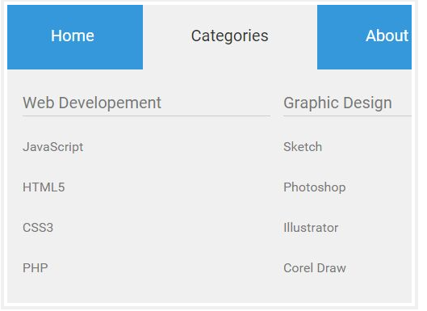

1. **Role based Login:**
2. Candidates
3. Leads
4. Admin

3. **Upload Image for Candidate/Lead**

Refer the below image:

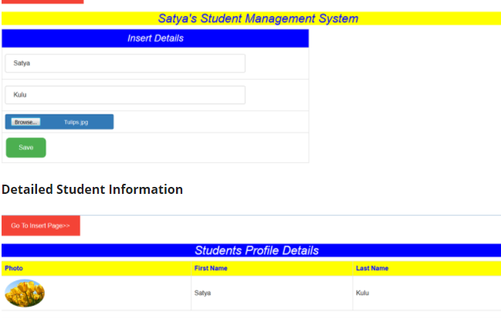

1. Insert, update or change/reshuffling the Candidates as per leads/Technology
2. Show the Image while selecting the records
3. Create a Web API application as back end, use MVC application for front end

Reference:

Mega menu: <https://www.jqueryscript.net/blog/best-mega-menu.html>

MVC File Upload: <https://www.c-sharpcorner.com/article/store-photo-in-backend-using-entity-framework-in-mvc-razor-and-bootstrap/>

Web API with MVC: <https://www.c-sharpcorner.com/UploadFile/4d9083/how-to-create-web-api-in-Asp-Net-mvc/>

<https://www.tutorialsteacher.com/webapi/consume-web-api-get-method-in-aspnet-mvc>